Toruń Model United Nations
Official Instruction Booklet

Contents

Preparation and Research
Researching Your Delegation
Researching Your Issues
(M)UN Structure
Writing a Policy Statement
Sample Policy Statement
Writing a Resolution
Resolution Format
Useful Preambulatory Phrases
Useful Operative Phrases
Sample Resolution
Rules of Procedure
Flow of Debate
*Making Amendments
Voting Procedures
Flow of Debate in ‘At Hoc’ Committees
Making Amendments in
‘At Hoc’ Committees
Voting Procedures in ‘At Hoc’ Committees
How to Lobby
Points and Motions
MUN Glossary
General Information and Rules
The Idea of MUN
Attendance
Dress code
Notes
Lunch
Housing
Cloakroom
Smoking and drinking

Preparation and Research

Preparing for any MUN conference is a process of searching for useful information and learning anything that could help you in the course of debate. Even if you are more of an improvising type, having some background information on the issues you will be discussing and on the country you will be representing is always helpful and therefore strongly recommended. Just think of all the ways you could use your knowledge while writing a resolution or defending it in your committee. For example some less-known facts on the issues are amazing for writing speeches, as they might surprise your listeners or even impress them. Also the more information you have, the better you understand your position as a delegate of a given country while discussing a particular issue. Having your research well done makes you feel more comfortable and confident during the debate (especially true for beginner MUNers). While for some people preparing for the conference is a “necessary evil”, some of them find it interesting or even exciting. Whichever type you are, here is a list of four essential steps to follow in the process of your preparation:

- Research your delegation (→ page 3)
- Research your issues (→ page 4)
- Explore the UN structure, focusing on the committee you are in (→ page 5)
- Study the rules of procedure (→ page 14)

Researching Your Delegation
In order to keep the course of the conference as close to the actual United Nations debates as possible, all delegates must make sure they are well prepared for the role they are to play. That will be the role of an official representative of the assigned country/organization. There are plenty of sources that could help you “do your homework”. Make an effort to find them and use them for your research. Below, please find how you could use the Internet for this purpose.
As for books, you can try to search for useful information in Encyclopedias, World Atlases and any publications you manage to find, although it is no secret that at this point using the Internet is both quicker and more effective.

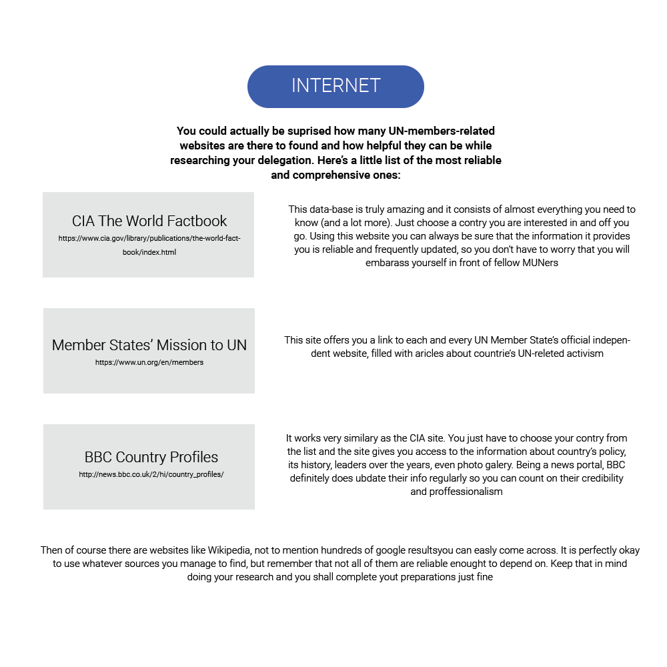

Researching Your Issues

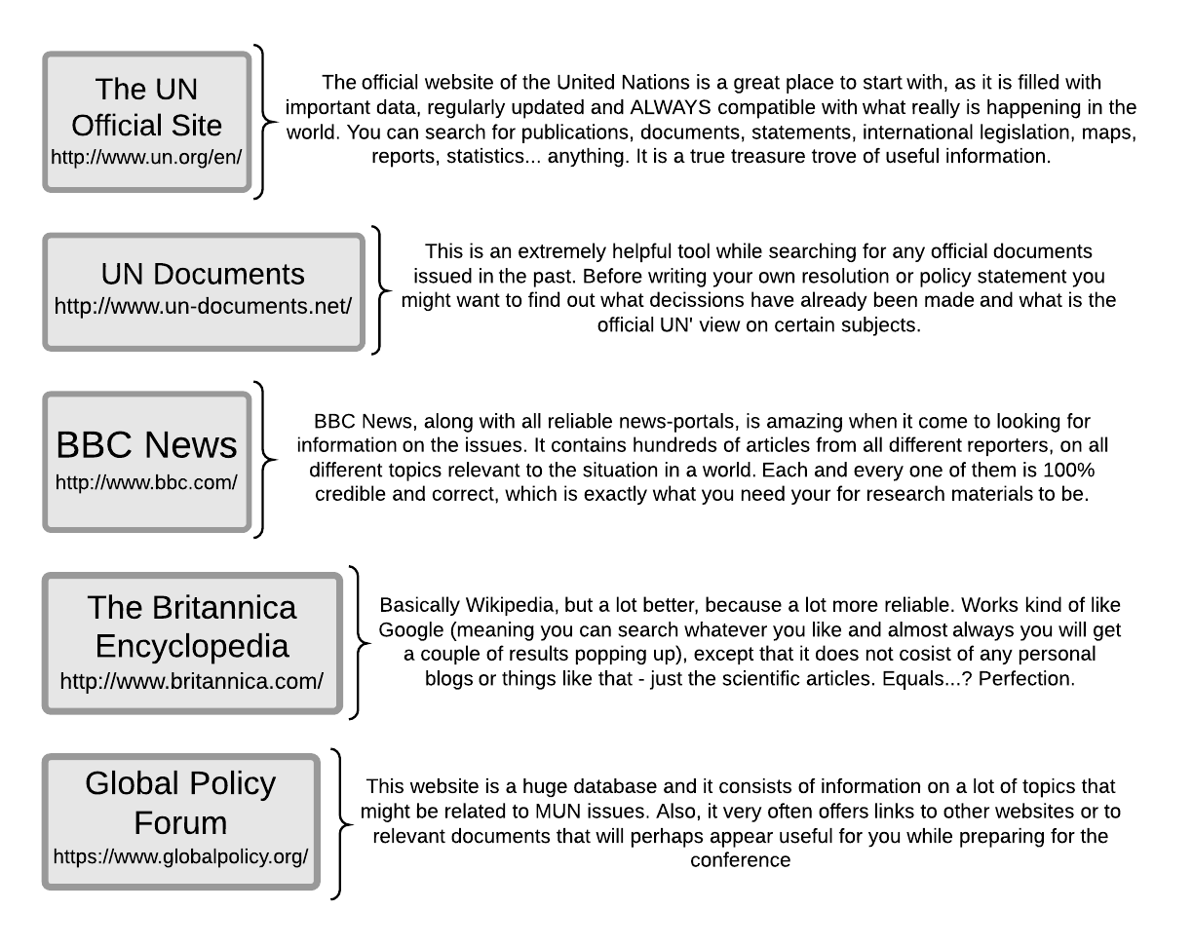
When it comes to researching your issues, you are not completely on your own, as you can rely on Research Reports, provided by the Student Officers. However, you still have some work to do yourself. That is because Research Reports only give you the general picture of an issue, not specifying particular countries’ statements. Therefore it is up to you to collect information on your country’s policy with regard to the issues discussed in your committee. Now, while researching an issue you will probably come across both old and new information. You need to properly order it (chronologically) so you do not get all tangled-up and confused. Please notice that it would be advisable for you to search for all different kinds of information, such as historical facts, opinions, news, statistics, etc. Importantly, adopt the right, positive attitude, helpful in committing yourself to hard work. There are a lot of sources that will help you through it.

MUN Structure

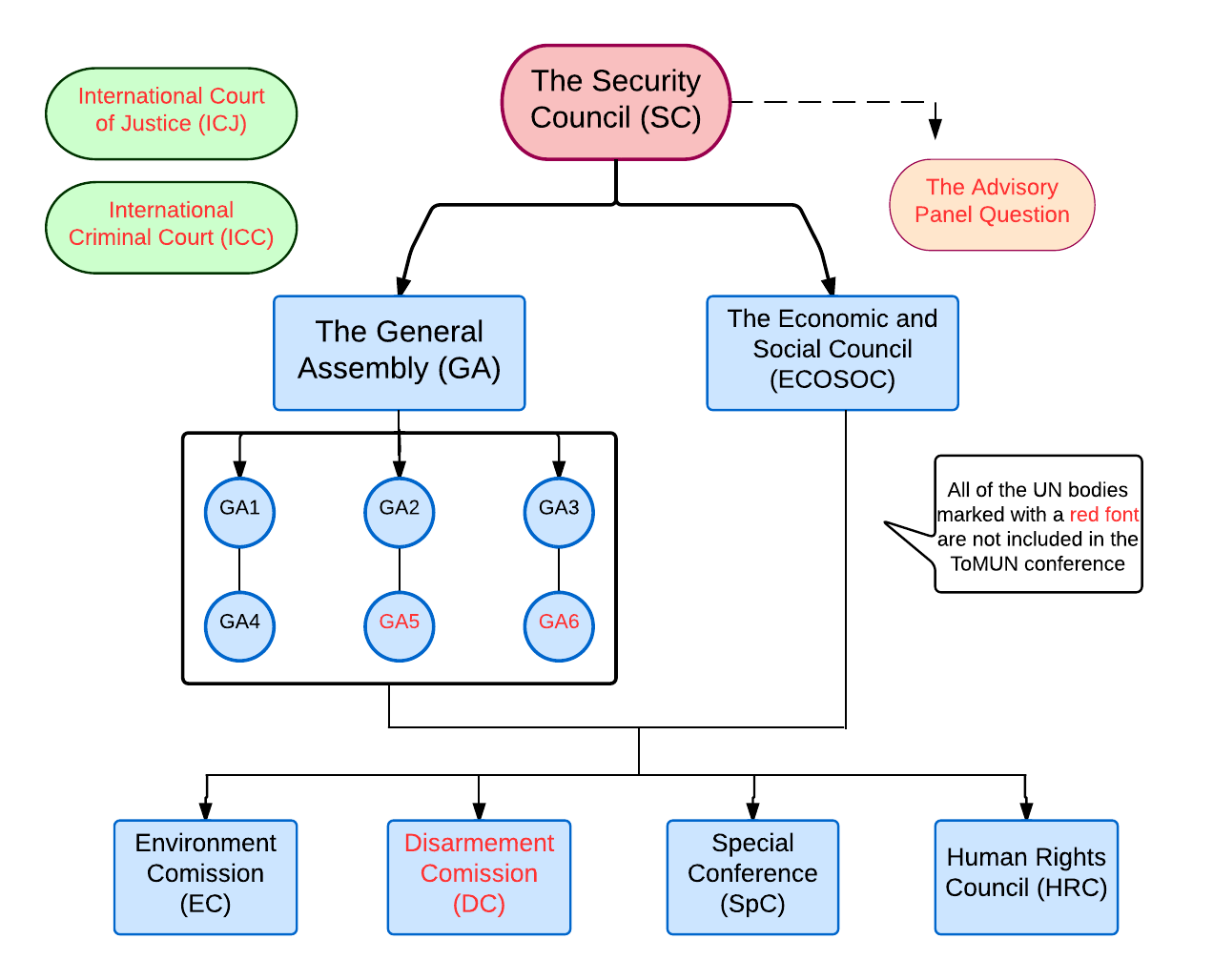

GA1 - Disarmament and International Security
GA2 - Economic and Financial
GA3 - Social, Humanitarian and Cultural
GA4 - Special Political and Decolonization

Writing a Policy Statement

In preparation for a MUN conference, delegates should write policy statements, which are documents that briefly and clearly explain the policies of the delegate’s country/organization with respect to the issues dealt with in respective committees at the conference. It appears important to write policy statements as they serve as reference documents for delegation members and committee members during the conference. Additionally, policy statements may provide an excellent tool in the lobbying process; they may also serve as the basis for your opening speech in your committee.
In order to produce a useful policy statement, delegates ought to carry out thorough research. In a policy statement, the delegate should remember to include the following:

- Explain and define the issue and its most important terms;
- Provide a short summary of recent international action related to the issue;
- Refer to key documents that relate to the issue;
- State the country’s general position on the issue;
- Briefly make suggestions that are in line with their country’s policies to provide a solution to the issue.

At the top of the policy statement, please include an appropriate heading. The Heading includes the name of the country/organization providing the statement, the name of the Committee/Council, and the issue the statement relates to (agenda topic). Policy statements should not be too detailed on the issue in question, as this is what resolutions should do. Make sure your policy statement does not exceed 400 words.

Sample Policy Statement

Delegation: Republic of Korea
Forum: GA3
Question of: Creating a universal response plan focusing on how to act after natural and nuclear disasters

The Republic of Korea is aware that the immediate effects of natural and nuclear disasters include loss of life and damage to property and infrastructure, with the survivors (some of whom may have been injured in the disaster) traumatized by the experience, uncertain of the future and less able to provide for their own welfare, at least in the short term. More than likely, they are left without adequate shelter, food, water and other necessities to sustain life. Although natural and nuclear disasters are very different, the consequences following each remain similar, and so do the actions taken in order to reinstate the functioning of the region engulfed by a certain disaster.
South Korea is certain that the primary aims of disaster response are: rescue from immediate danger, stabilization of the physical and emotional condition of survivors and recovery of the dead. To ensure these measures governments must focus on creating positive value and strengthening human solidarity as means of helping communities better withstand sudden shocks and urge them to help each other. Governments can take steps in advance and promote voluntary actions, so that after a disaster occurs people are ready to help, if not financially than by voluntary commitments.
The Republic of Korea is aware that these are measures taken on a small scale. For full recovery countries damaged by disasters need outside help. The Republic of Korea approves of associations such as the ASEAN Regional Forum (ARF) (responsible for formal, official, multilateral dialogue in The Asia-Pacific region) whose job is to expand sister city agreements and hold a summit by Japan, China and South Korea toward cooperation on disaster response and environmental issues. The Republic of Korea is convinced that strong regional cooperation is a valuable factor in rebuilding destroyed land.
Moreover facilitating charitable/voluntary organizations in places threatened by disaster is highly significant as quasi-public groups like the Red Cross have disaster response as their central mission. With organizations of this kind comes organized help followed by, but not limited to: medical staff, technicians for reconstruction and volunteers.
So that countries are not limited to outside help the Republic of Korea advises governments to develop disaster management units that will provide operational support and services in disaster response and disaster response preparedness. This goes hand in hand with the restoration of essential services such as water and power. To assure these, the countries located in areas threatened by natural disasters or the ones owning a nuclear power plant must be equipped in additional power sources.
South Korea is aware of the difficulties following both natural and nuclear disasters. We believe that by strong international cooperation and commitment of people living in disaster-vulnerable areas it is possible to rebuild what has been destroyed.

Writing a Resolution

Resolution Format
By definition, United Nations resolutions are formal documents, expressions of the opinion or will of United Nations organs. They generally consist of two clearly defined sections: a preamble and an operative part.

The preamble generally presents the background of the issue in question, the considerations on the basis of which action is taken, an opinion expressed or a directive given.

The operative part states the opinion of the organ or the action to be taken.

At the top of the resolution, please include an appropriate heading.
The Heading at the top of the resolution is very important as it is used to facilitate the work of the Secretariat and the Committee Chair in processing the draft resolution. The Heading includes the subject of the resolution (agenda topic), the name of the Committee/Council to which it will be presented, and the name or names of the countries submitting the draft resolution, as well as the Draft Resolution Number. The number is in numerical order based on the order in which the draft resolution is introduced to the committee.
It is advisable that the perambulatory part is concise in content, providing the key points illustrating the background of the issue in question and/or its historic justification. It is essential that each preamble clause begins with a relevant preambulatory phrase, which is highlighted (e.g. underlined or in italics). Each preamble clause should end with a comma.
The operative part is the more important part. Its purpose is to develop the points stipulated in the preamble part accordingly, and to provide relevant solutions to the problem(s) listed in the topic and in the preamble. The arguments used should be sound, and the actions to be taken should be described in as much detail as possible, supported with examples, which can be enumerated in sub-clauses. Each operative clause should end with a semi-colon.

Sub-clause pattern:
1.
2.
3.
(a)
(b)
(c)
(i)
(ii)
(iii)

Each sub-clause should end with a comma, except for the final sub-clause, which should end with a semi-colon, as it marks the end of the entire operative clause.
During lobbying, delegates will look for other delegates within their respective committees who will support their draft resolution. When they have found ten such delegates, they will go to the computer room and start merging their drafts and/or working together on the final version of their resolutions. The main submitting country/ies will be called SPONSOR(S) in the final draft resolution, and the co-submitting countries will be called SIGNATORIES. This information should also be included in the heading of the final (merged) draft resolution. The draft resolution remains a draft until it has been debated and voted upon. Then it becomes a resolution.
In writing your draft resolution, be detailed; if your resolution calls for a new program, think about how it will be funded and what body will manage it. Try to cite facts whenever possible. Be realistic; do not create objectives for your resolution that cannot be met. Make sure your body can take the action suggested. For example, the General Assembly cannot sanction another country – only the Security Council can do so.

Useful Preambulatory Phrases

Affirming  Alarmed by  Approving  Aware of  Bearing in mind  Believing  Confident  Contemplating  Convinced  Declaring  Deeply concerned  Deeply conscious  Deeply convinced  Deeply disturbed  Deeply regretting  Desiring  Emphasising  Expecting  Expressing its appreciation  Expressing its appreciation  Fulfilling  Fully alarmed  Fully aware  Fully believing  Further deploring  Further recalling | Guided by  Having adapted  Having considered  Having considered further  Having devoted attention  Having examined  Having heard  Having studied  Keeping in mind  Noting with regret  Noting with satisfaction  Noting further  Noting with approval  Observing  Reaffirming  Realising  Recalling  Recognising  Referring  Seeking  Taking into account  Taking into consideration  Taking note  Viewing with appreciation  Welcoming

Useful Operative Phrases

Accepts  Affirms  Approves  Calls  Calls upon  Condemns  Confirms  Congratulates  Considers  Declares accordingly  Deplores  Designates  Draws the attention  Emphasises  Encourages  Endorses  Expresses its appreciation  Expresses its hope  Further invites | Further proclaims  Further reminds  Further recommends  Further requests  Further resolves  Has resolved  Notes  Proclaims  Reaffirms  Recommends  Regrets  Reminds  Requests  Solemnly affirms  Strongly condemns  Strongly urges  Supports  Takes note of  Transmits

All of the phrases in red type can only be used by the Security Council and no other committee

Sample Resolution

FORUM: GA3
QUESTION OF: Making safe abortions possible for victims of rape in LEDCs
SUBMITTED BY: Saudi Arabia

GENERAL ASSEMBLY 3rd COMMITTEE

Fully alarmed by the fact that in many LEDCs rape is committed every few minutes on average,

Alarmed by the fact that figures on the number of cases of rape are more often than not
unreliable because rape is a taboo subject,

Deeply concerned by the fact that a large percentage of rape victims in LEDCs are children,

Emphasising that in many countries rape is not a reason to perform an abortion,

Keeping in mind that lack of allowance will not stop rape survivors from getting abortions, but it will only encourage them to perform them in breach of law, which will only result in damage to health or death of patients,

1. Expresses its appreciation of organisations, such as Lawyers Against Abuse, taking action to ensure that rapists are held accountable for their crimes;

2. Encourages more developed countries to send emissaries to set up medical
establishments where rape victims can receive treatment and/or information, inter alia about safe methods of abortion, such as:
a. dilatation and evacuation (D&E),
b. medical methods (mifepristone and misoprostol),
c. curettage,
d. manual vacuum aspiration;

3. Urges the governments of the states where rape has been used as a weapon in the event of unrest to recognise rape victims as war victims, which will grant them the rights and privileges thereof;

4. Calls the governments of LEDCs to recognise rape as a sufficient reason to perform abortion on rape victims;

5. Suggests that, once abortion is considered legal in the case of rape victims, hospitals in LEDCs should be subsidised and provided with the following:
a. qualified staff,
b. professional equipment,
c. post-abortion care wards,
d. necessary medicaments;

6. Emphasizes the importance of education in LEDCs in order to render rape victims aware of how to receive help, what abortion is and how to perform it safely as well as stop abortion from being a taboo issue;

7. Further emphasizes the importance of implementing punishments, such as
imprisonment, deprivation of the rights to practise the profession, for illegal abortion providers, including but not limited to women performing abortions on themselves;

8. Reminds that rapists are not always strangers, but also spouses, which is often
disregarded by society;

9. Draws the attention to the costs of dangerous abortions not only to women, but also to their existing children, partners and families and to health services and society as well;

10. Further draws the attention to the fact that female victims are more likely to report on sex crimes to female police officers;

11. Further recommends to recruit more women to police forces;

12. Calls for UN officers’ monitoring investigations of rape cases in LEDCs, and for intervention when corrupt police officers and court officials deny services and take bribes from rapists;

13. *Decides to remain actively seized of the matter.

* The last operative clause, at least in the Security Council, is almost always "Decides [or Resolves] to remain seized of the matter," (sometimes changed to "actively seized"). It appears to be an assurance that the body in question will consider the topic addressed in the resolution in the future if it is necessary.

Rules of Procedure

Flow of Debate
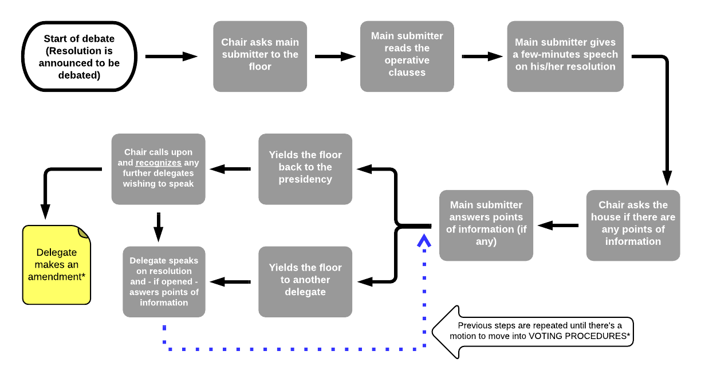
The diagram below is an overview of the course of debate in all of the General Assemblies, ECO-SOC, EC, HRC and the Special Conference. Of all the committees we have included in ToMUN 2015, the Security Council is the only one that performs its debate differently, as they do not discuss a submitted resolution as a whole, but submit one clause at a time (a statement) and discuss it on an ad-hoc basis.

Please notice that before a committee starts debating on resolutions, all delegates are given the time to lobby. Lobbying is a very exciting part of every MUN conference, as it gives you an opportunity to use your diplomatic skills and your persuasiveness to grasp other delegates’ interest in your ideas and solutions to particular issues (your draft resolution). If you would like to get more specific information about lobbying, please move to the section of the booklet entitled How to Lobby. We have prepared a similar diagram that will walk you step by step through the entire process of lobbying.

*Making Amendments

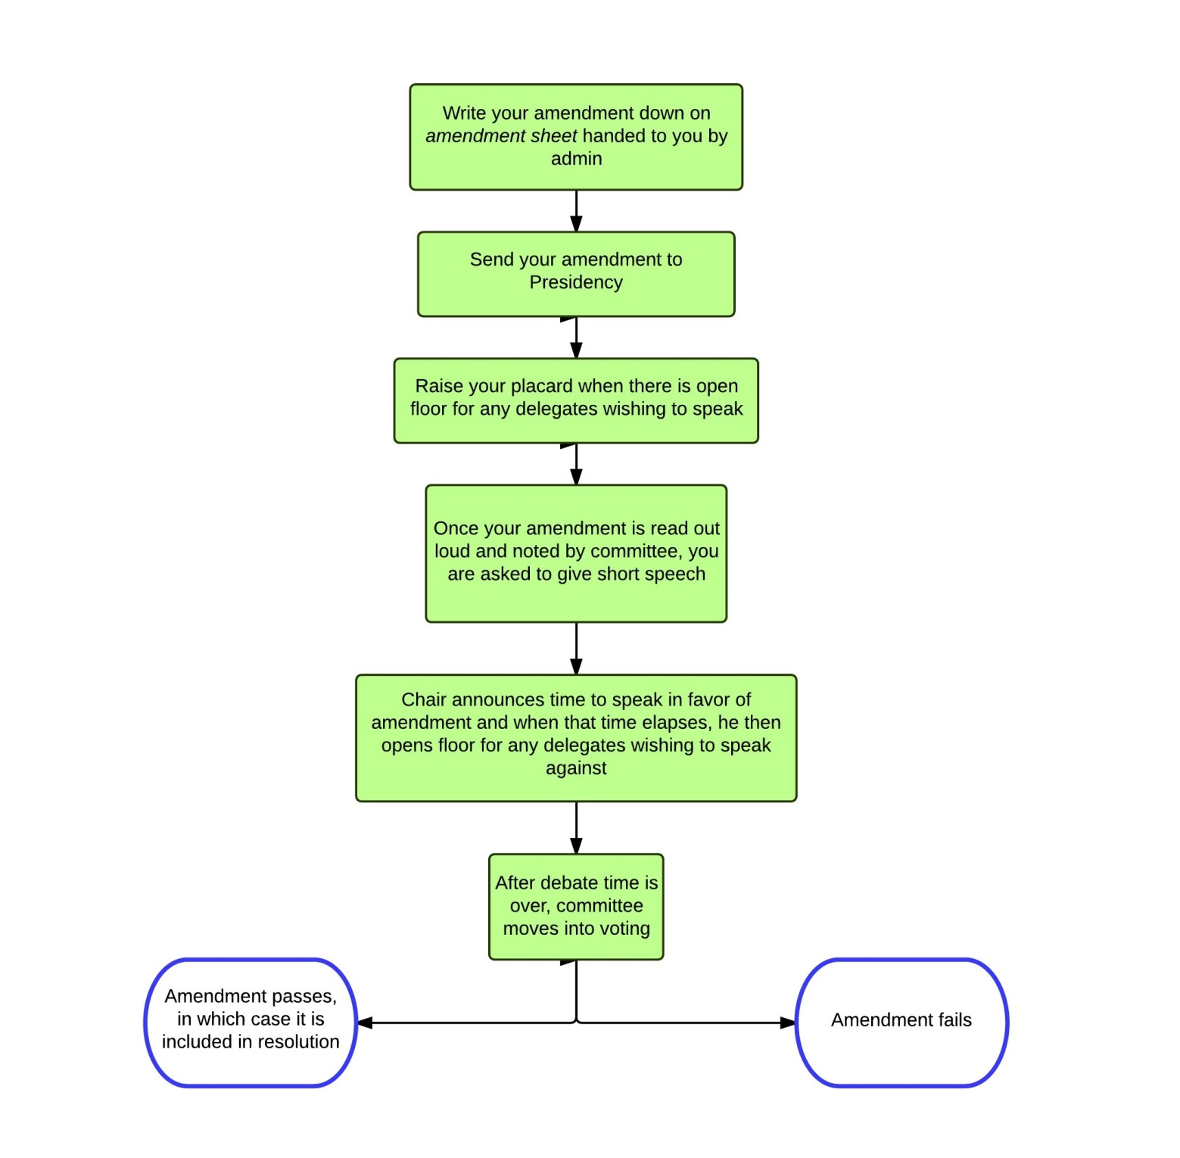

Voting Procedures

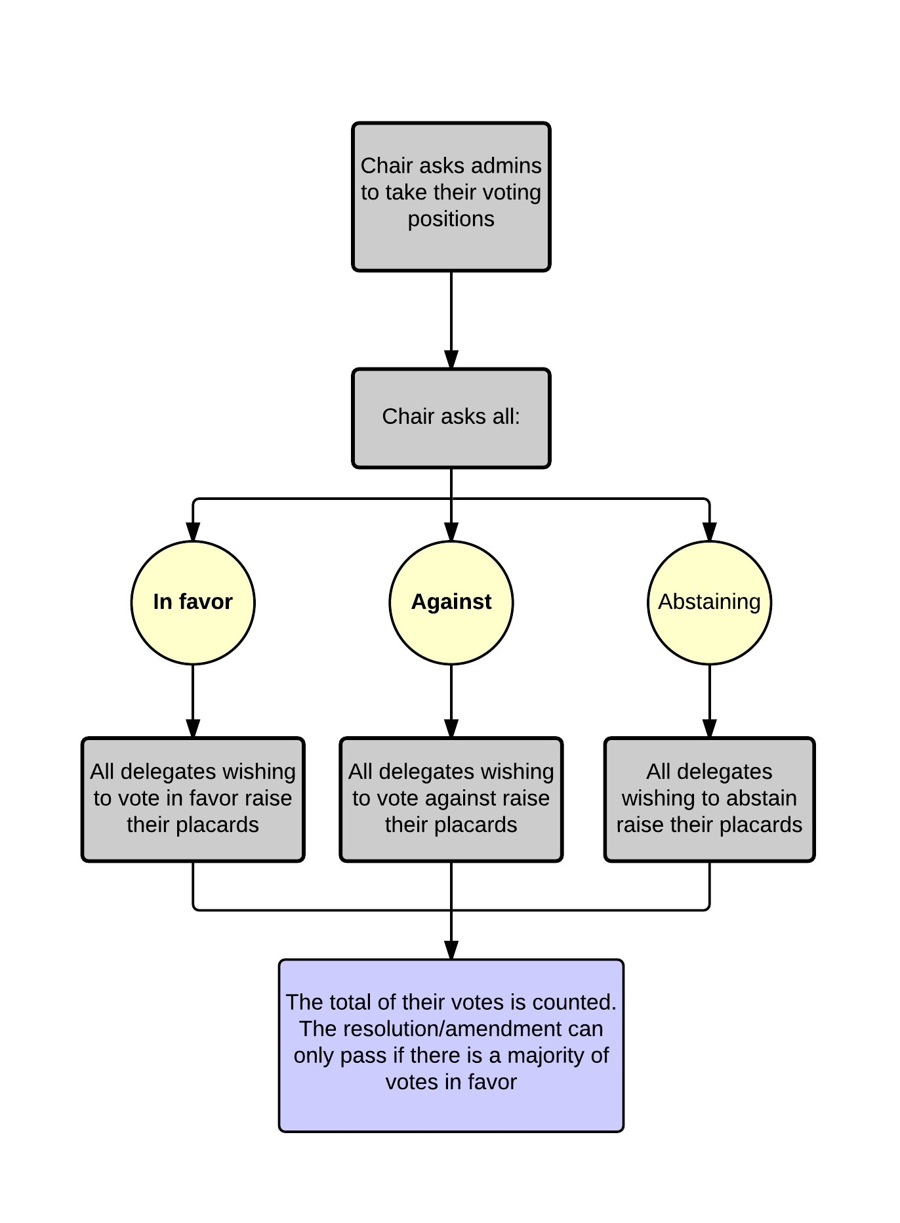

Flow of Debate in ‘At Hoc’ Committees

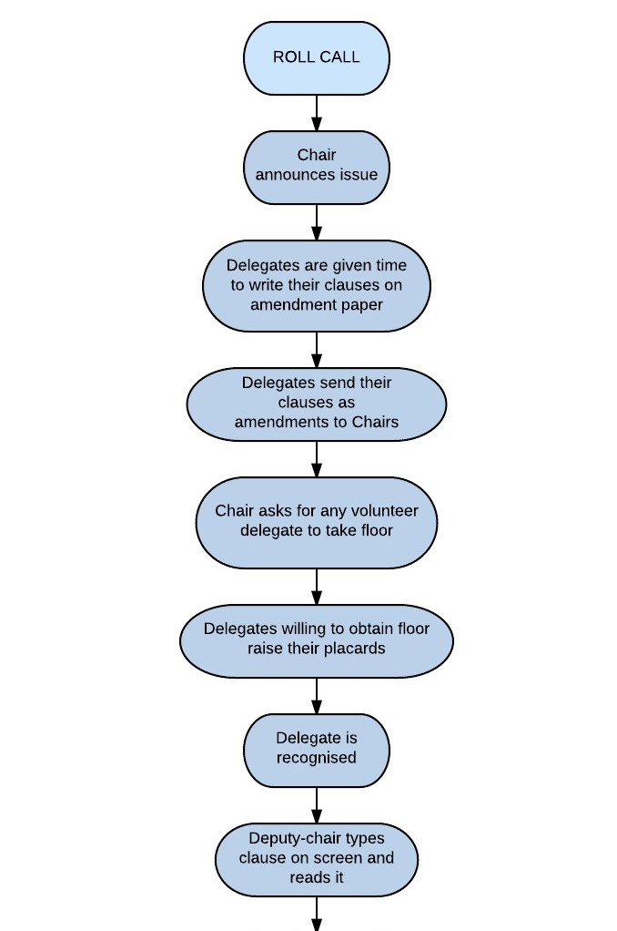

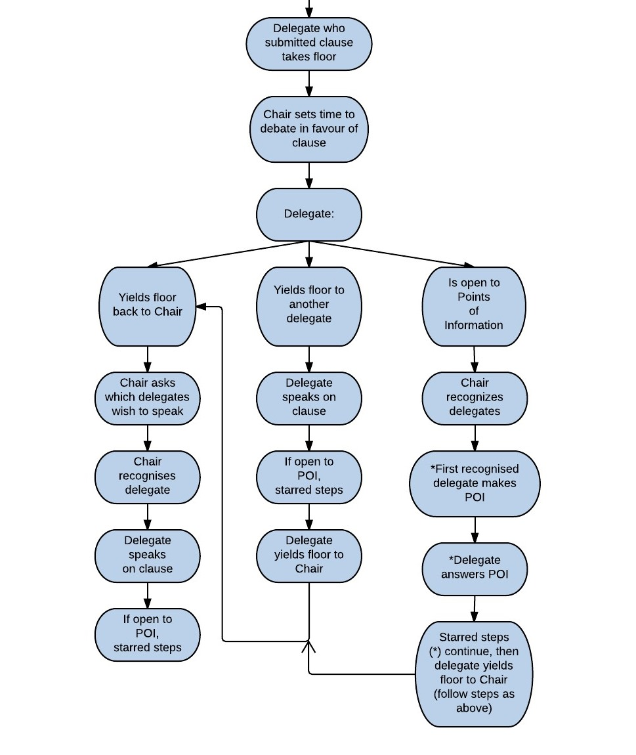

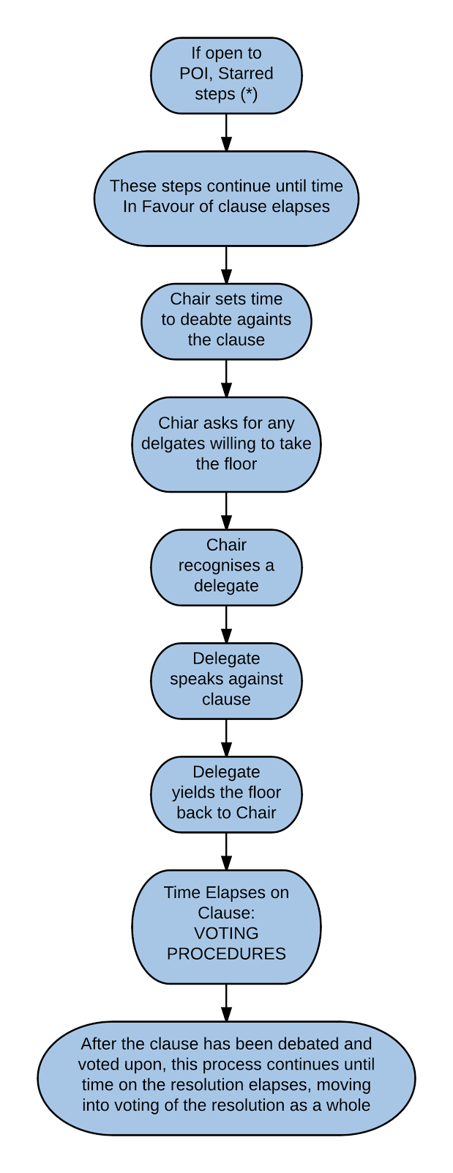
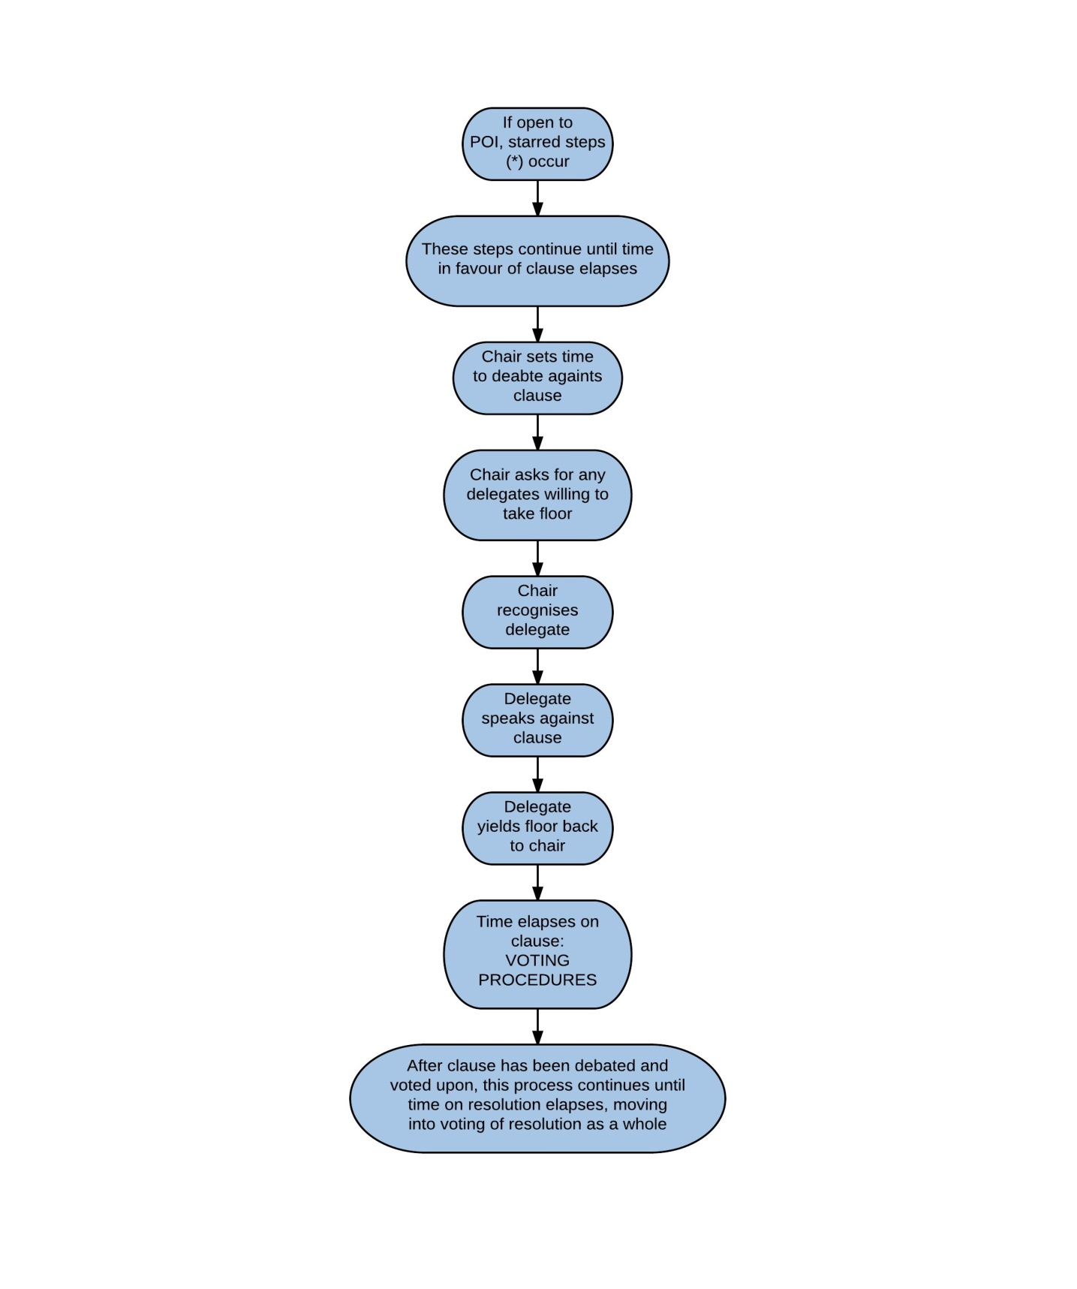

Making Amendments in‘At Hoc’ Committees

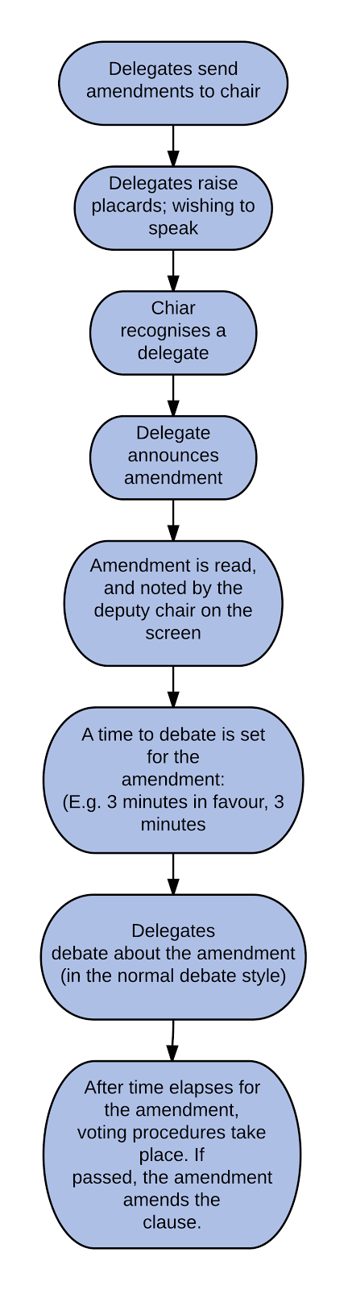

Voting Procedures in ‘At Hoc’ Committees
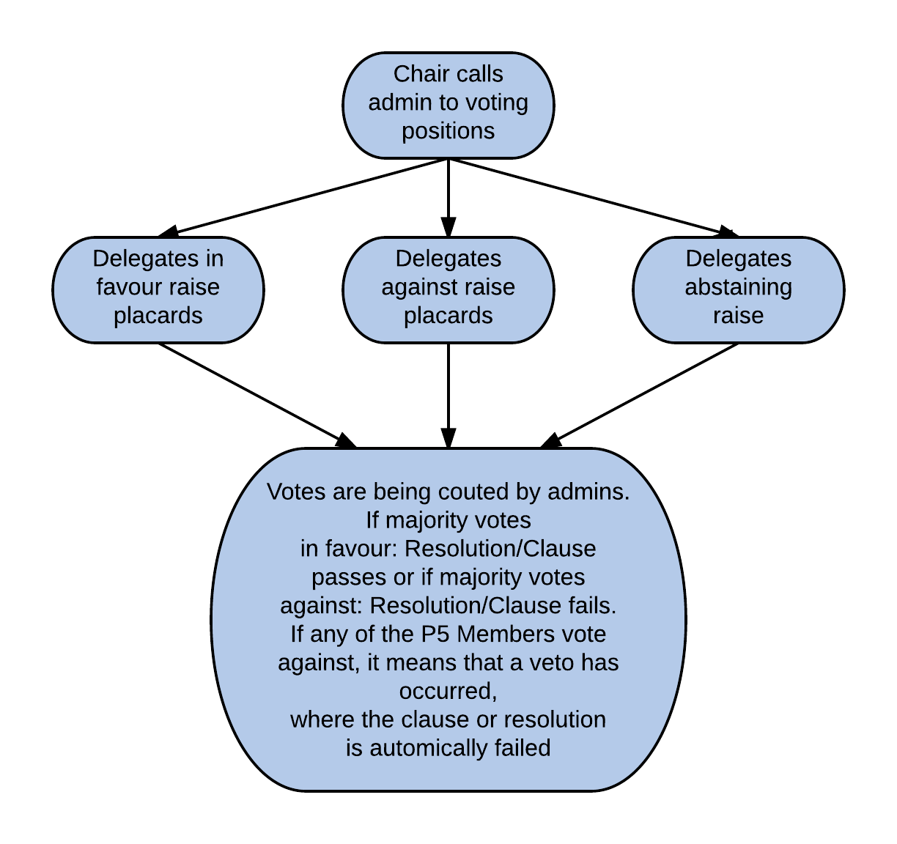

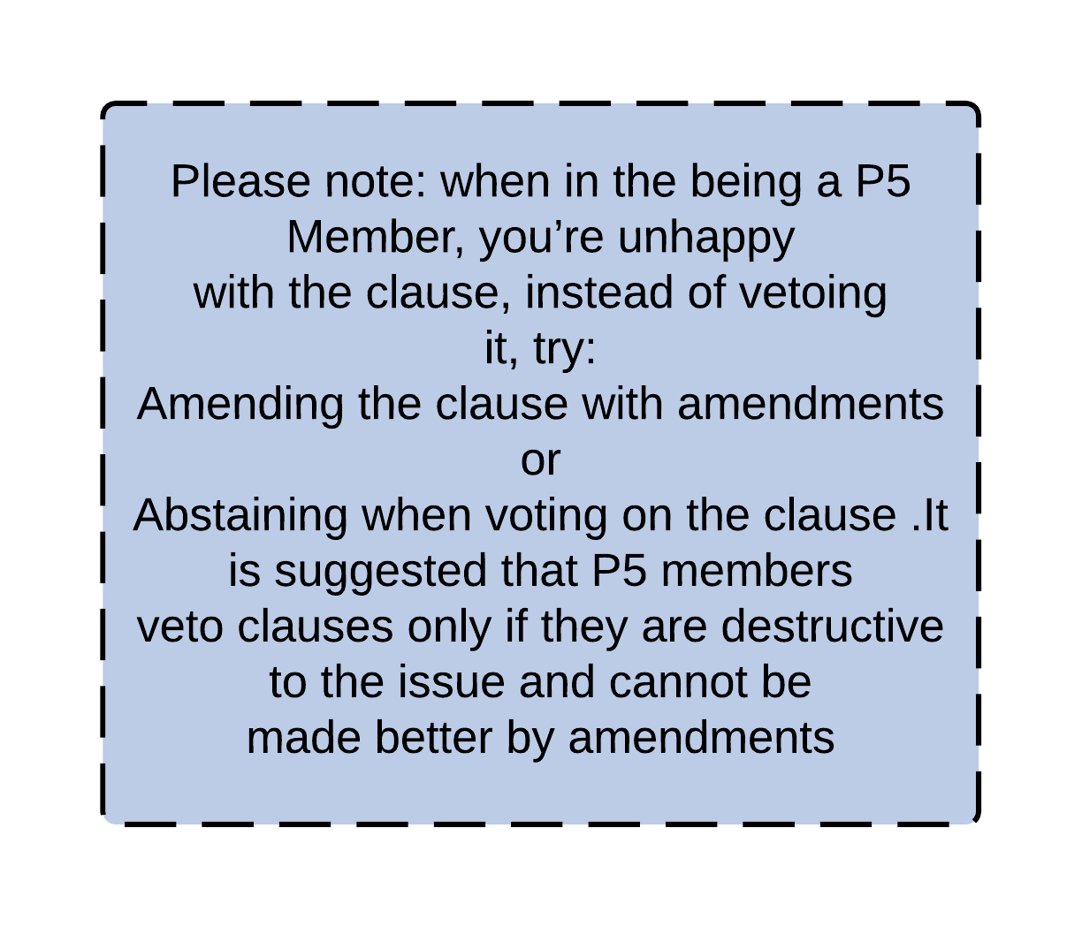

How to Lobby

Lobbying is a very important part of the conference for two major reasons:
- it allows you to do some final work on your resolution and improve any of its aspects that needs improvement,
- it prevents similar resolutions from being debated.
Lobbying will also give you an idea of who will support or oppose your resolution during debate, it will show what aspects of your resolution still need improvement, clarification or exemplification.
The actual purpose of lobbying is to find other delegates who share your ideas and political views on the issue(s) in question, and could potentially become your allies in the course of debate. Once you manage to do that, you begin to compare and discuss your resolutions, so that you can improve them by rewording, adding clauses or merging your resolutions into one. Remember that even if you all work on it together, you still have to choose one of you to be the main-submitter of the resolution, while the others remain its co-submitters. When you get that part over with, you start persuading other delegates to sign your resolution. This is an important phase of lobbying, because in case of your resolution not reaching the required number of signatures (co-submitters), it will not be in order for this resolution to be discussed in your committee. Once you are all done with perfecting your resolution and collecting the required number of signatures, the effect of your hard work goes to the members of the Approval Panel, who check it for grammar and format errors.
Please note that when deciding whether or not to co-submit somebody’s resolution, you should keep in mind that undersigning this document is a diplomatic commitment. Signing a resolution and becoming its co-submitter makes you officially obliged to defend the resolution during debate, which will be expected of you.
As a MUN delegate, you always have to remember that you represent the interests of a particular country or organisation that you are assigned to, not your own ideas, claims or beliefs. Since our goal is to keep the conference as a simulation of the actual UN, therefore it is necessary for all the delegates to be prepared for their role. That is why we encourage you all to do your research and meticulously collect the information on the policy of the country you represent in order not to appear incompetent or ignorant. Here is a detailed diagram that illustrates the entire process of lobbying step by step.

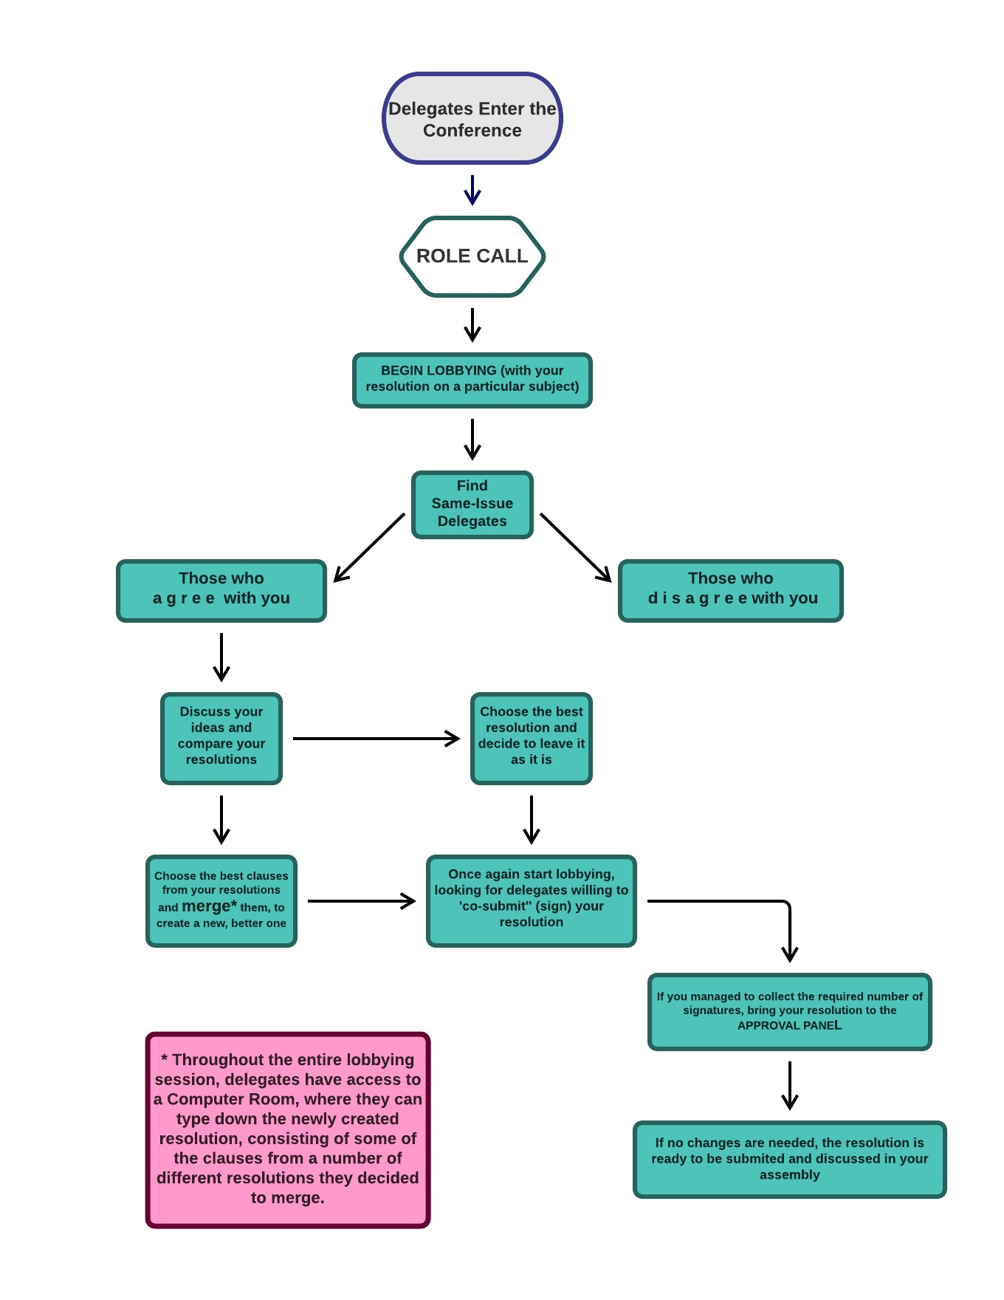

Points and Motions

POINT/MOTION | MAY INTERRUPT THE SPEAKER? | SECOND | SPEAKERS | VOTE (after an objection) | DESCRIPTION
Point of personal privilege due to audibility | Yes | No | None | No | To notify the Chair that you can’t hear the speaker.
Point of personal privilege | No | No | None | No | To notify the Chair that you are experiencing discomfort.
Point of order | No | No | None | No | To notify the Chair that a mistake has been made regarding the Rules of Procedures.
Point of parliamentary inquiry | No | No | None | No | To ask the Chair a question about the Rules of Procedure.
Point of information to the Chair | No | No | None | No | To ask the Chair a question about something not concerning the Rules of Procedure.
Motion to move to the previous question | No | Yes | 2 against | 1/2 majority | To ask the Chair to move to the time against when in a closed debate, if it is the time in favor.
Motion to move to the voting procedures | No | Yes | 2 against | 1/2 majority | To close the debate on the current amendment/resolution.
Motion to extend debating time | No | Yes | 1 in favour  1 against | 1/2 majority | To extend debate time on the current amendment/resolution.
Motion to divide the house | No | Yes | None | 1/2 majority | To propose a roll call vote.
Motion to table the resolution | No | Yes | 1 in favour  1 against | 2/3 majority | To adjourn debate on the current resolution.
Motion to adjourn debate | No | Yes | None | 1/2 majority | To propose a break.

Glossary of MUN Terms and Phrases

General Assembly (GA) – in the real UN, it is the body in which every country of the world is represented. Even though we won’t have all the countries present at our Conference, the GA is still our biggest committee that every delegation will attend. Sometimes (in the MUN world) the General Assembly may be also called the Plenary Session.

Specialized Committee (or Regional Body/Bloc) – A committee that is smaller than the GA, typically it contains 20-30 delegations. The specialized committees are usually focused on particular geographic area (such as the African Union, or League of Arab States), or on a particular problem

Debate – is what goes on in the committee. Formal debate is governed by the Speakers’ List and moderated by the Chairperson. Debate is regulated by official Rules of Procedure.

Chairperson (Chair, Chairman, Chairwoman) – the person who is responsible for the smooth running of the Committee. He/she writes the study guides, moderates the entire proceedings of the Committee, decides on some matters that are at his/her discretion and generally does everything to keep the debate smooth and productive.

Speakers’ List – is the order in which delegations will address the Committee. It is the backbone of the proceedings; it gives the Committee a basic structure.

Caucus – ia an opportunity for a less formal debate for a duration of the caucus delegates are not according to the speakers list. There are two kinds:
- Unmoderated Caucus – delegates are free to discuss without the guidance of the Chairperson or the formal rules.
- Moderated Caucus – Speakers’ List is abandoned; delegates raise their placards to speak and the Chairperson chooses the next speaker.

Floor – essentially means the opportunity to speak, or it can denote the subject matter that is currently debated. If someone “has the floor”, it means they are allowed to speak. If a resolution is “on the floor”, it has been formally introduced, it is being debated and it will be voted on.

Placard – the sign that has the name of the country you are representing on it. You raise your placard to vote or to propose a point or motion – it is a way for the Chairperson to see you have something to say.

Gavel – the little wooden hammer the Chairperson uses to keep the Committee in order. Make sure they don’t have to use it too much, banging the gavel does not make a very pleasant sound.

Dais – officially, the table upfront behind which the Chairperson is sitting. Practically, the Dais denotes also the Chair and the staff of the Committee. Any concerns related to the proceedings of the Committee you may have you should address to the Dais. Same goes for notes to the Chairperson, or resolutions/amendments you want approved.

Procedural – all points/motions that have something to do with the official procedure of the debate – e.g. motions for caucuses, motion for a roll call, etc...

Substantive – all matter that has to do with the content of the Committee session – generally related to draft resolutions or amendments.

Point – if you want to ask a question, or point the attention of the Chairperson to something, you use a Point. For example, when you cannot hear the speaker, when you think the Chair has made a procedural mistake, or when you do not understand the decision of the Chair and want to clarify the procedure. There are three types of Points (Point of Personal Privilege, Point of Parliamentary Inquiry and Point of Order); for further explanations please see the Rules.

Motion – motion is essentially a suggestion for action to the Committee. If you want to change the way of debating, introduce a resolution or generally move the proceedings forward, raise your placard and make a motion. There are several types of motions allowed in a Committee – for their list and further explanations, see the Rules.

Second – whenever a motion is made, it requires a Second – that is, there needs to be another delegation that wants to see the motion implemented. To Second is easy – when you hear a motion you agree with, just raise your placard and say “Second”.

Yield – is what you do with the remainder of your speaking time. Yielding essentially means giving the rest of your time to someone. You may yield to other delegation, to questions (if you are willing to answer them), or to the Chairperson (if you have finished speaking or you have no more time anyway). For further info see the Rules.

Roll Call – when the Chairperson reads the names of all delegations in alphabetical order, to see if they are present (or to hear their vote, in a Roll Call voting).

Working Paper – a document that is authored by one or more delegates, presented to all delegations, and which helps the work of the Committee in some way. It does not have to be in a resolution format, it can be a list of ideas; nevertheless, a good working paper provides a backbone for a resolution.

Resolution – is the final product of the Committee. It is a document that says how you want to change the world; what actions you want to take; how you are using your authority as a body. A resolution is created during the Committee sessions and in the end you vote on whether to implement it or not. Resolution has to be in a specific format, it is made of clauses and it has two main parts:

- Preamble / Preambulatory clauses – the introduction, in which you state upon what principles you are acting (or what values you are upholding with the resolution), what events you are condemning or congratulating, and/or what other documents were used as a basis for this resolution. Preambulatory clauses cannot be amended or divided out of a resolution.
- Operative clauses – these are the sentences that describe the actions you want to take (or want other organizations to take). You may directly order something to the bodies you have authority over, or urge independent organizations to take some action that is in their power. You may create new bodies, or terminate old ones. In operative clauses, you should also explain the financing mechanisms of your plan, as well as the enforcement mechanism it will use.

For more about resolutions, see the How to Write a Resolution article, sample resolution and, the Rules.

Clause – a paragraph in a resolution describing one specific guiding principle (perambulatory) or action to be taken (operative).

Sponsors – are the delegations that author a resolution, and are committed to supporting it.

Signatories – are the delegations that wish to see the draft resolution formally debated during the Committee session. They do not have to agree with the resolution; they just want to see it on the floor.

Amendment – is a change to the operative clauses of a draft resolution (after it is introduced but before it gets voted on. Just a reminder, preamble cannot be amended. There are two types of amendments:
- Friendly – all the sponsors agree to it and it becomes incorporated into the draft resolution automatically
- Unfriendly – not all the sponsors agree with it; therefore it will get debated and voted upon, before it can be incorporated into the resolution.

Straw Poll – a non-binding vote for the purpose of gauging the opinion of the Committee. If you want to see what everyone thinks about your proposal, you may make a motion for a Straw Poll – the Chair will then have the delegates simulate voting on the proposal, but the vote is only for information purposes – it is not binding and the count may, of course, change later.

to be in order – if a type of a point or motion is said to be “in order” it means that the rules allow you to make such a point or motion. E.g. “a motion for a roll call is in order only when voting on draft resolutions” means you may only move for a roll call during the final voting procedure, but not when voting on amendments or other motions.

to rule something out of order - when a chairperson rules something out of order, (s)he is basically saying either that the rules do not allow it, or that he believes it would hurt the committee and therefore he will not allow it (the second is sometimes also called “ruling something dilatory”). If a delegate is out of order, it means that the action s(he) has made (offensive speech, incorrect motion) is inappropriate at that time and will not be considered.

General Information and Rules

The Idea of MUN
Model United Nations is a simulation of the United Nations. Students represent various member states and/or organisations, and try to solve world problems by producing resolutions in specified Committees. The project of MUN helps future politicians and activists to acquire and perfect debating skills and procedures, but also raises young people’s awareness of the global issues and allows them to improve their written and spoken English. Despite all the rules and procedures, MUN is a fun project and should be treated as such; it is by no means to stress its participants.

Attendance
Participants are expected to be present at all times when their forum is in session, unless they have a permission from their MUN-Director to leave, of which they are supposed to inform their Chair in a timely manner. Roll sheets will be held and verified at the beginning of every session and after breaks. Unannounced non-attendance will be reported.

Dress code
We ask delegates to look and behave in a way that is expected of real UN diplomats. Male delegates are expected to wear a suit and a tie during the conference, and during speaking a delegate should wear his jacket. Female delegates are requested to wear knee length skirts. Modesty is much appreciated. Sneakers, denim and hoodies are not allowed. National dress and military uniforms are forbidden.

Notes
During debating time, all delegates are allowed to conduct correspondence by sending short notes to one another (the notes are passed around by admins). There are - however - several rules regarding to this privilege. Firstly, all notes should be written down on the notepaper, prepared specifically for that one purpose. If you for some reason do not have a notepaper, please report it to your chair. Keep in mind that the content of the notes has to be related to the issues discussed in the committee. Otherwise the note can be requisitioned and never make to its addressee, as the original point of establishing an inner correspondence system within the committee was to enable delegates to make allies or share ideas “outside” of an open floor of debate (NOT to enable them to socialize and flirt, while there is an ongoing debate on the table)

Lunch
Lunch will be provided from 11:30 to 13:30 on Saturday and Sunday. Delegates will be given lunch tickets and informed of their lunch break. Not turning up for debate also means no lunch ticket, and therefore no lunch.

Housing
All delegates to be housed will receive all relevant information regarding their housing and host family right after their arrival and will be picked up by their host families. We ask students to remember that they are guests and respect respective house rules. Host swapping is forbidden. Any problems should be reported to the Housing Managers.

Cloakroom
A cloakroom will be provided and will be supervised, but not guarded. The school and organisers cannot be held responsible for any goods that have been lost or damaged.

Smoking and drinking
Smoking is prohibited in the school premises. Alcoholic beverages must not be consumed during the conference. Legal drinking age in Poland is 18. Drug use will not be tolerated.

